Jeppiaar Institute of Technology

SRIPERUMBUDUR -631 604,Kanchirupam District ,Tamil Nadu

DEPARTMENT OF INFORMATION TECHNOLOGY.

WEB PHISHING DETECTION

(**ASSIGNMENT -2)**

DATE : 23-11-2022

PROBLEM : TO ANSWER THE QUESTIONS FOR THE ANSWERS

NAME: DEVASASTHA

The [Dataset](https://drive.google.com/file/d/1_HcM0K8wt4b7FMLkc1V1dv0y6I_9ULzy/view) we have used Churn_modelling.csv

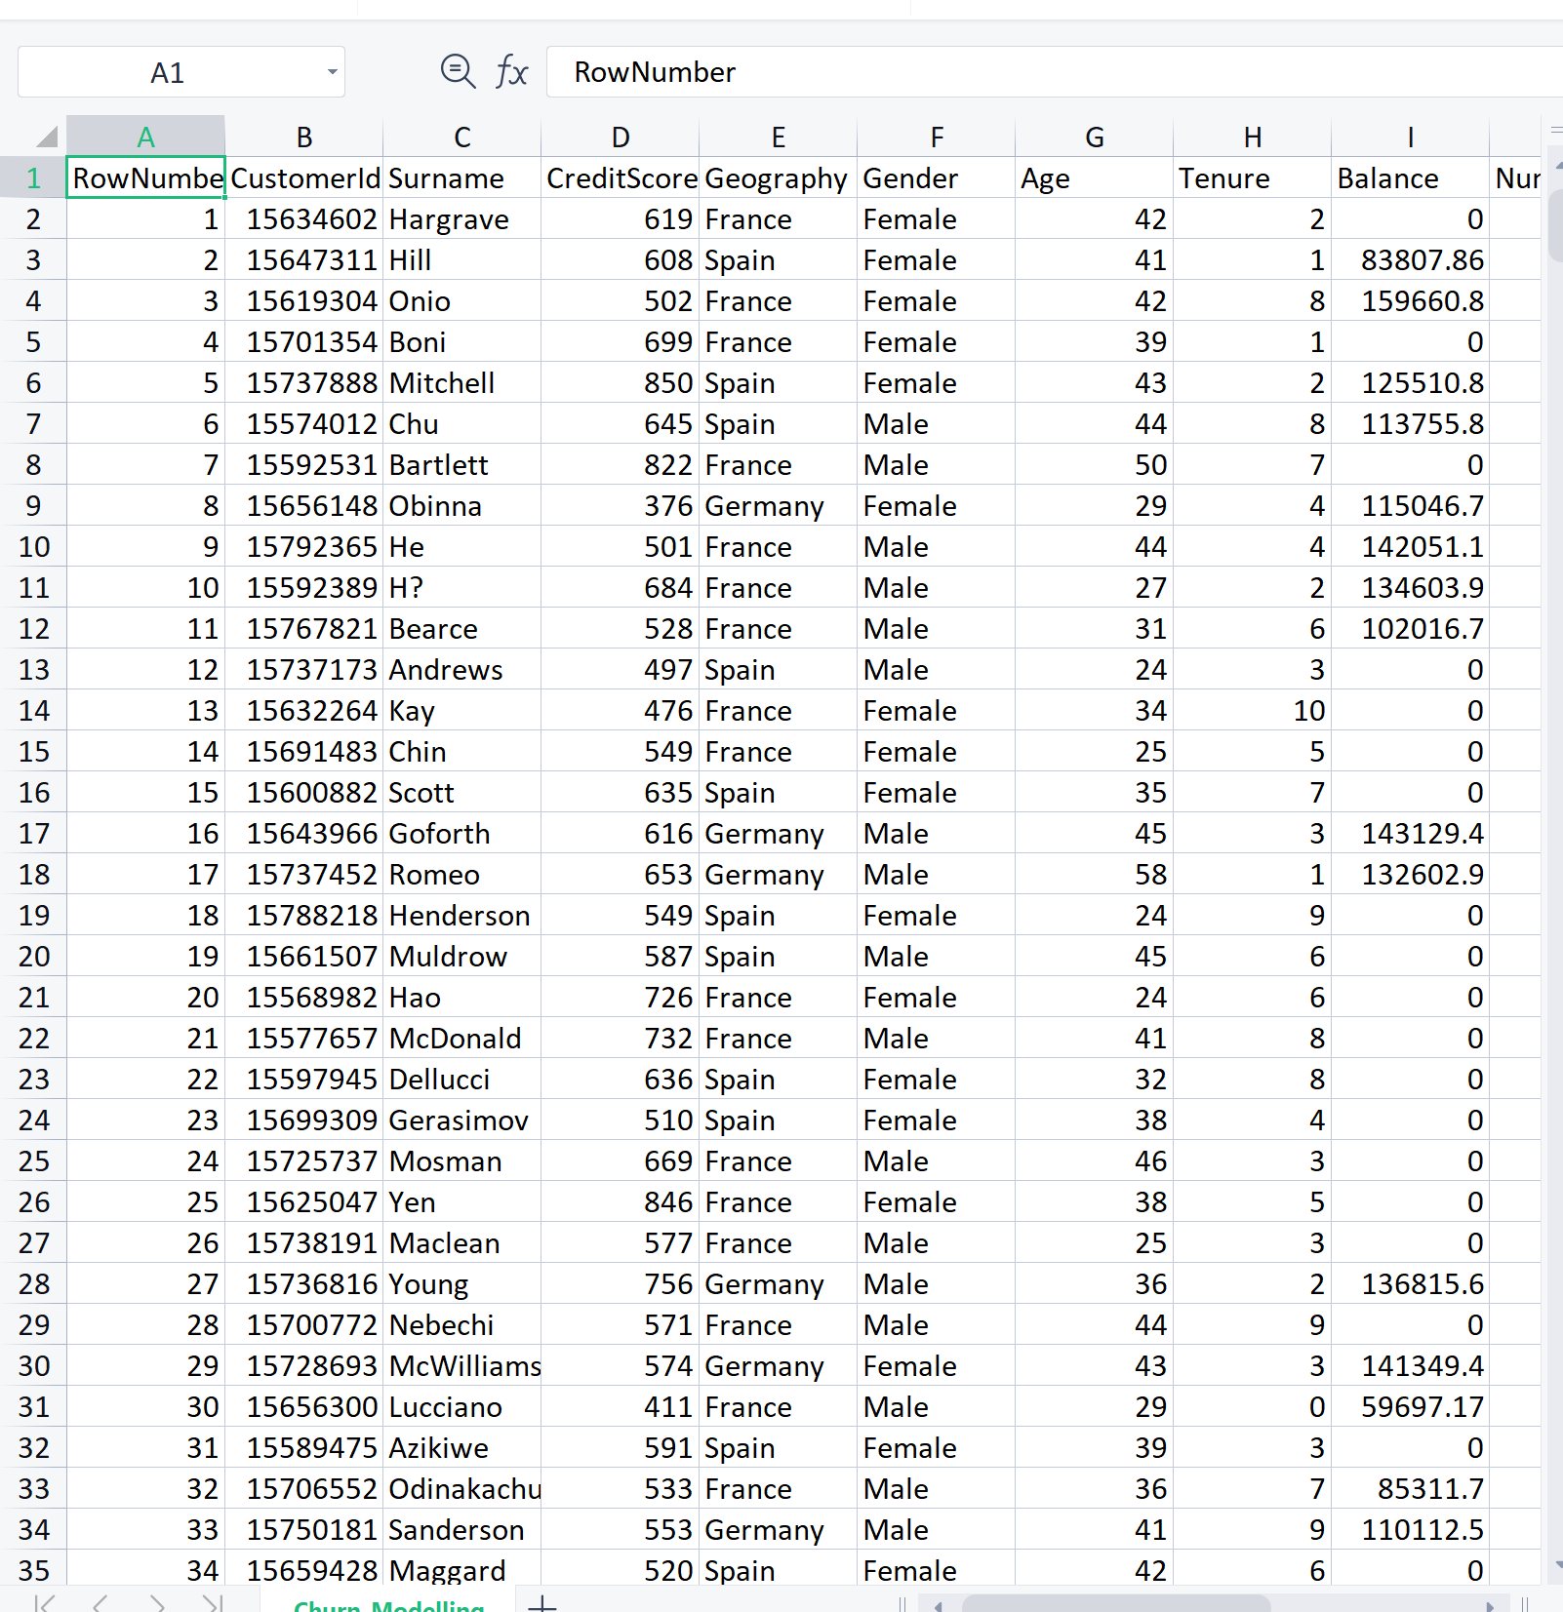

OUTPUT : SCREENSHOTS:

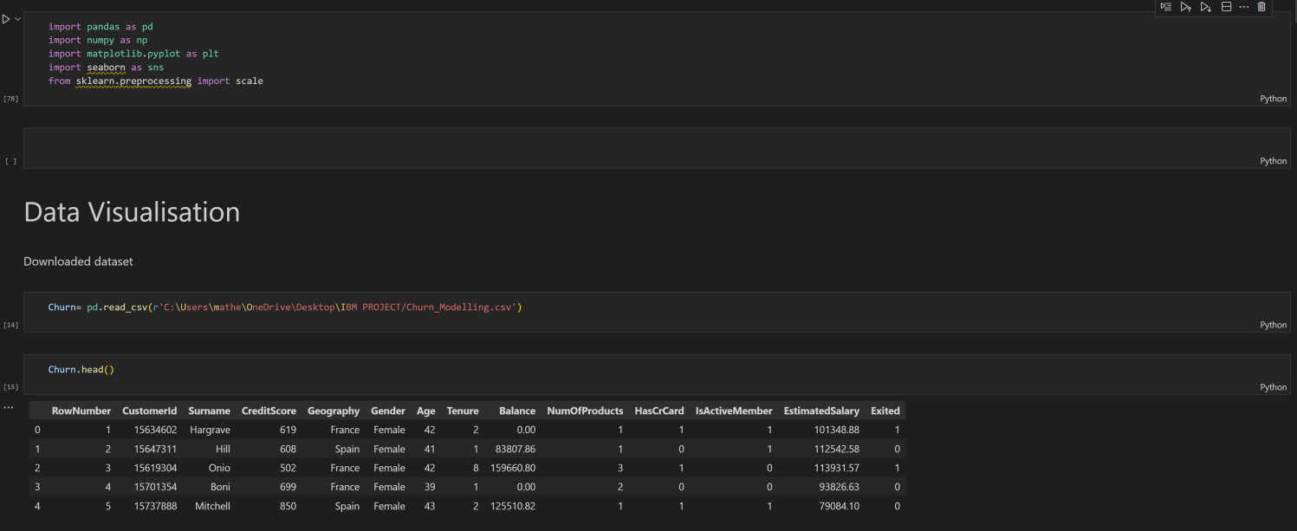

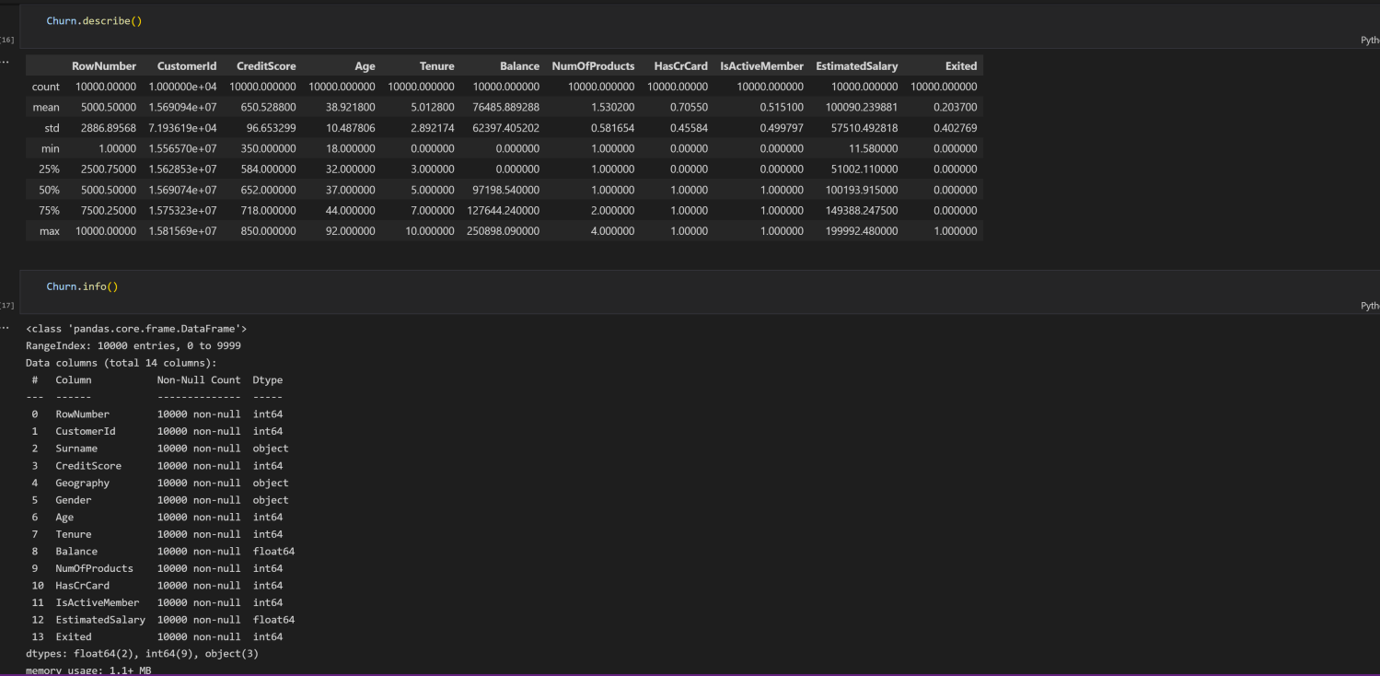

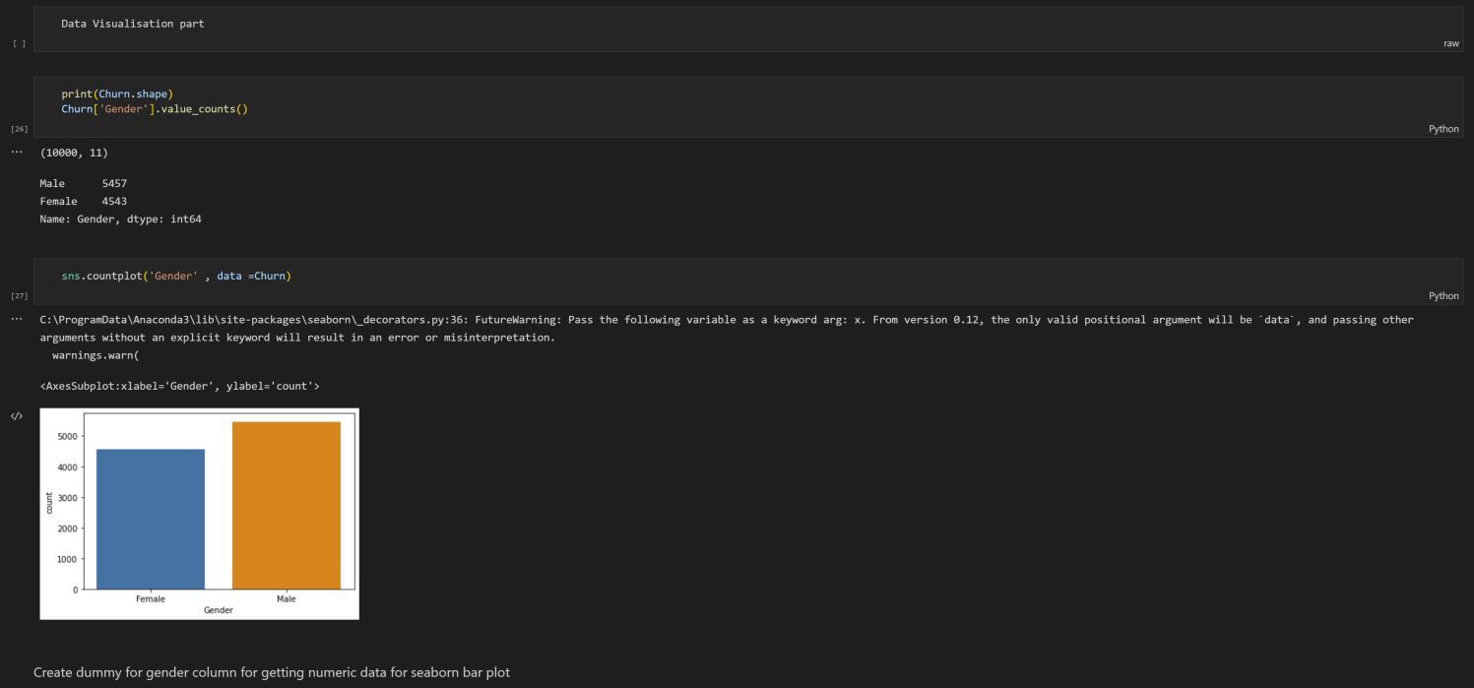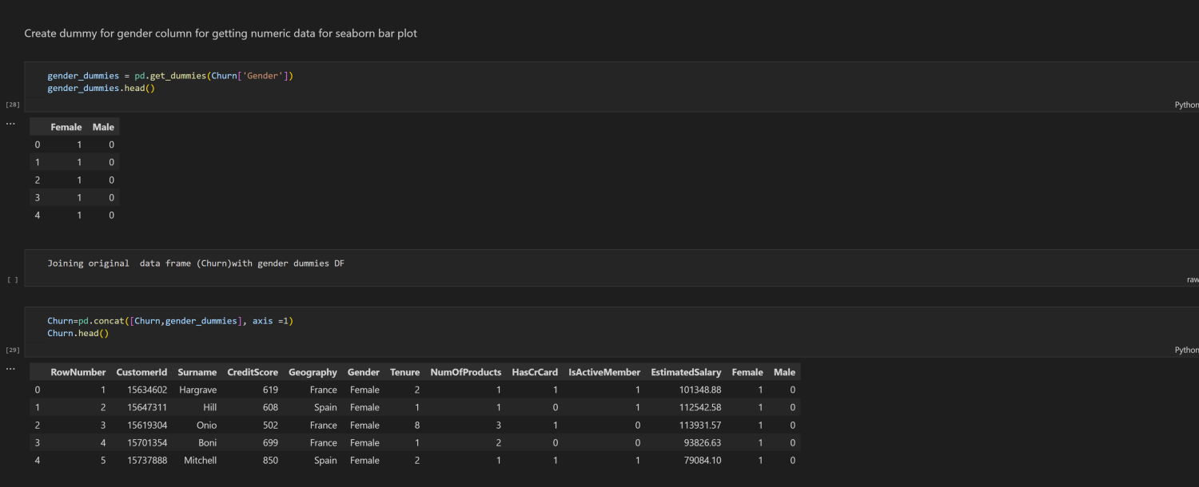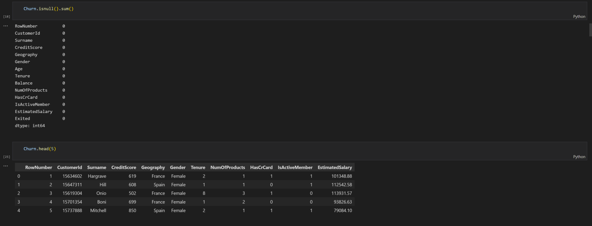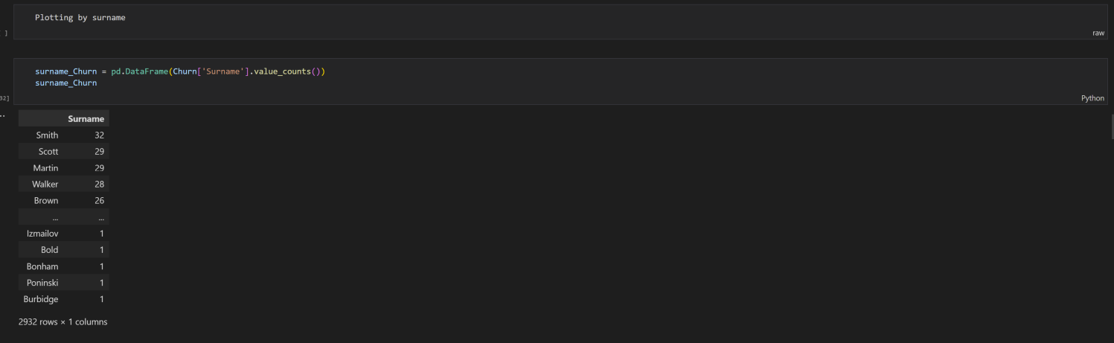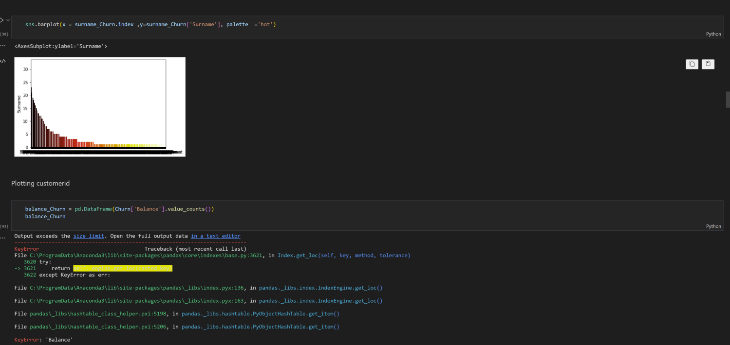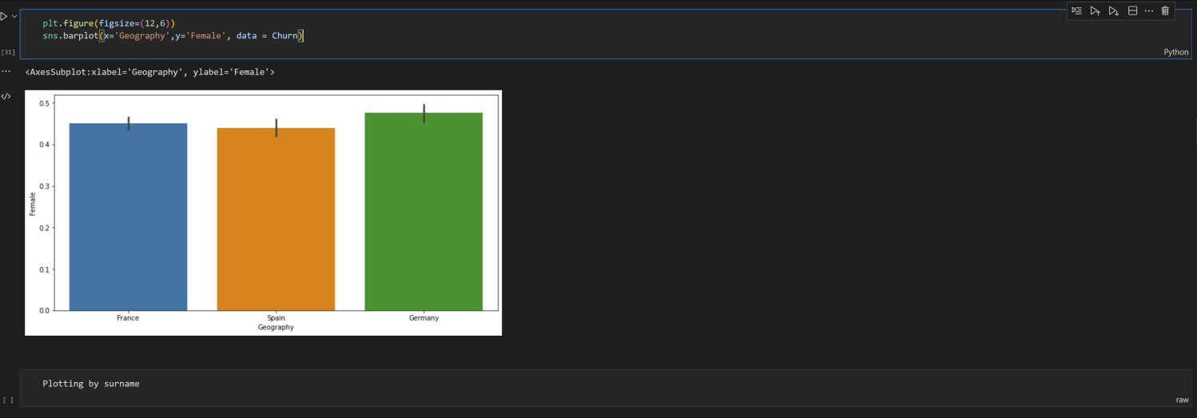

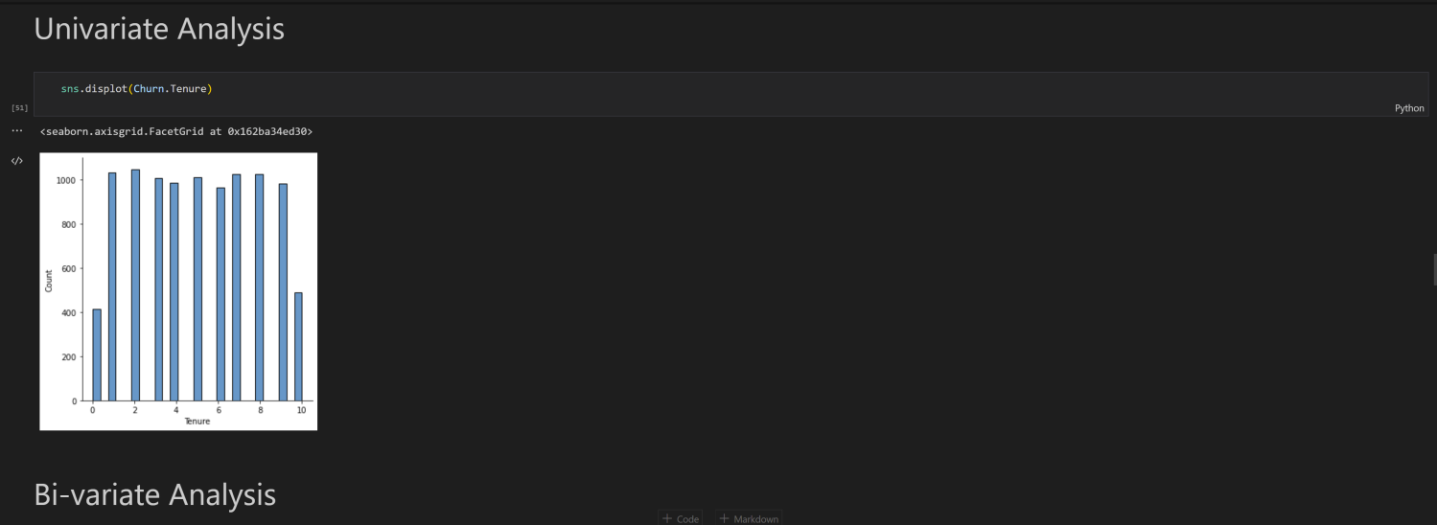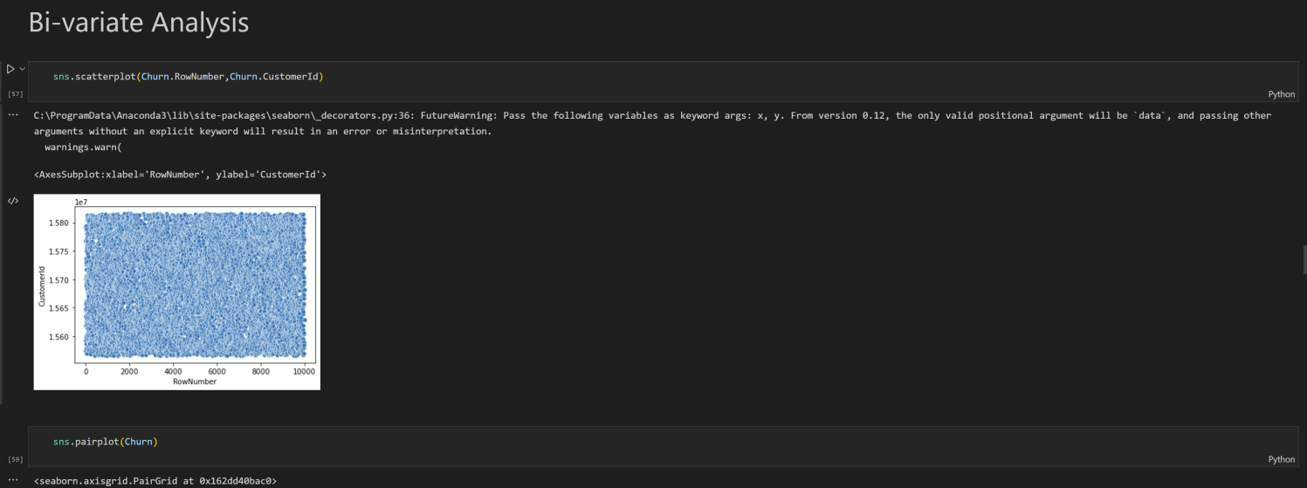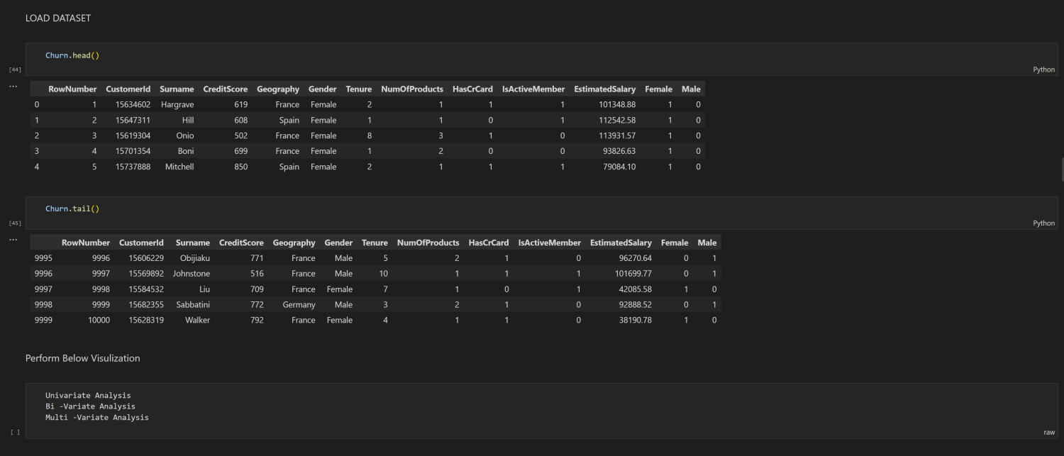

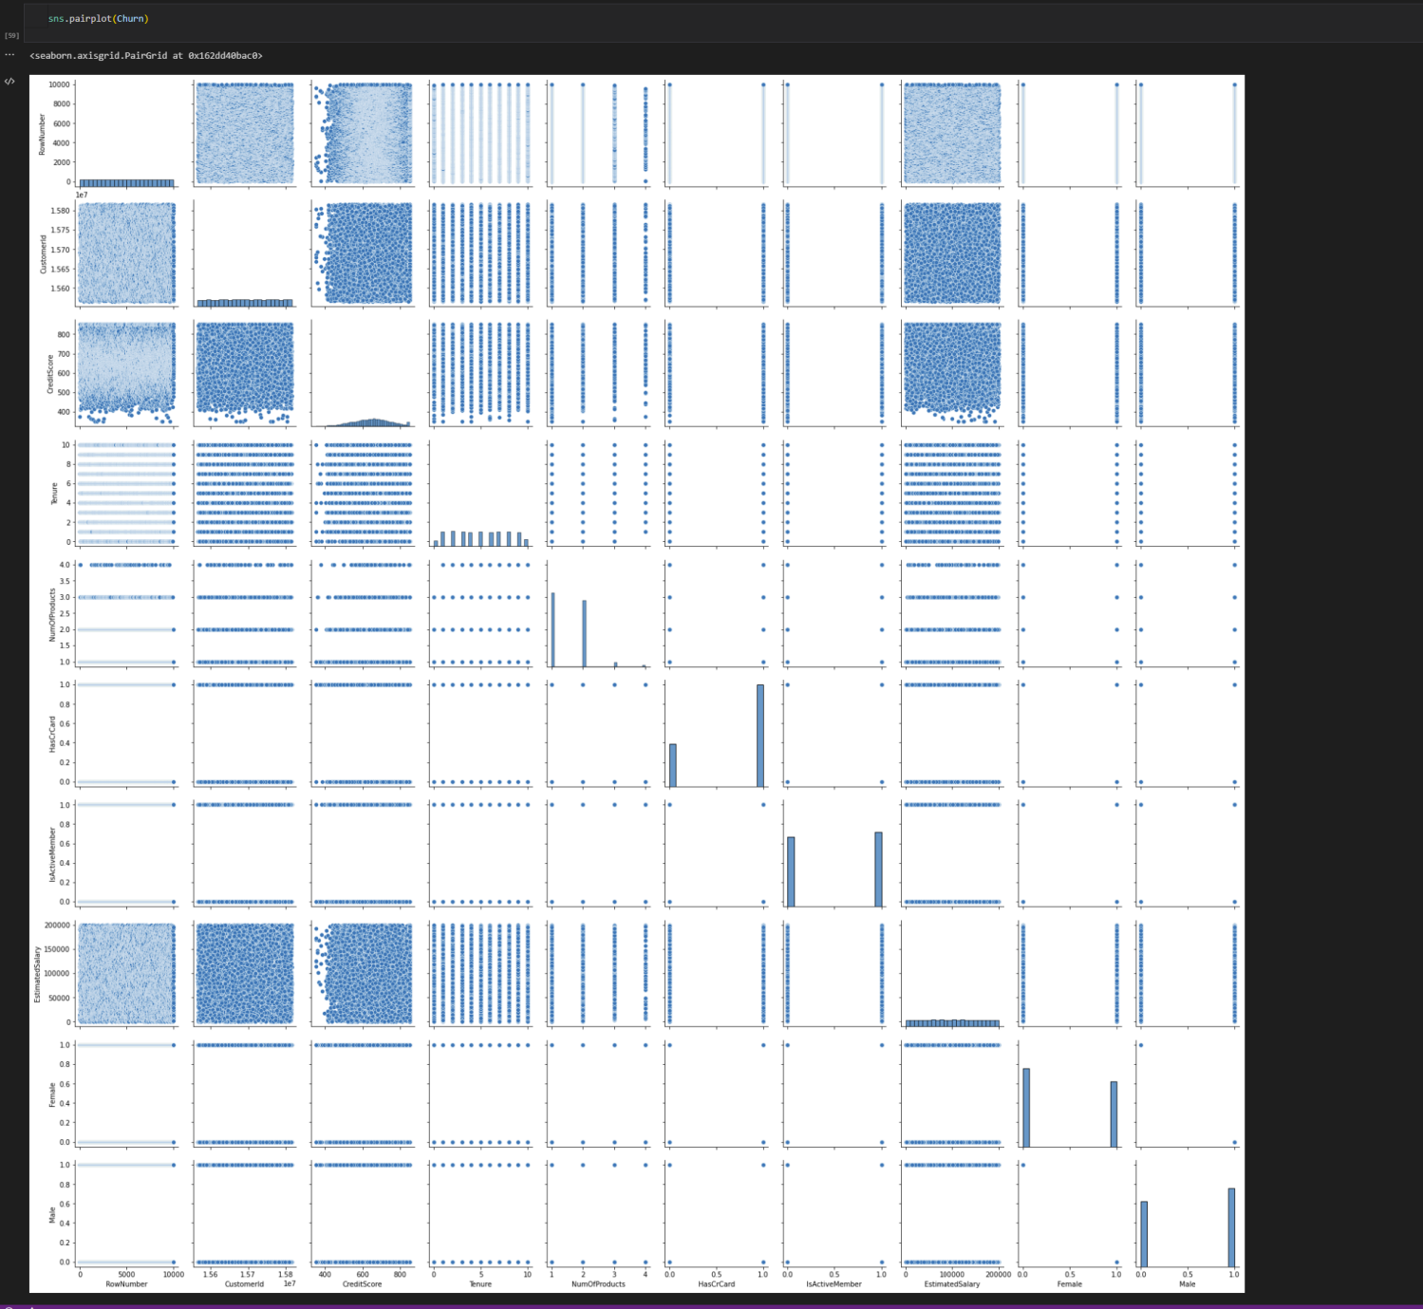

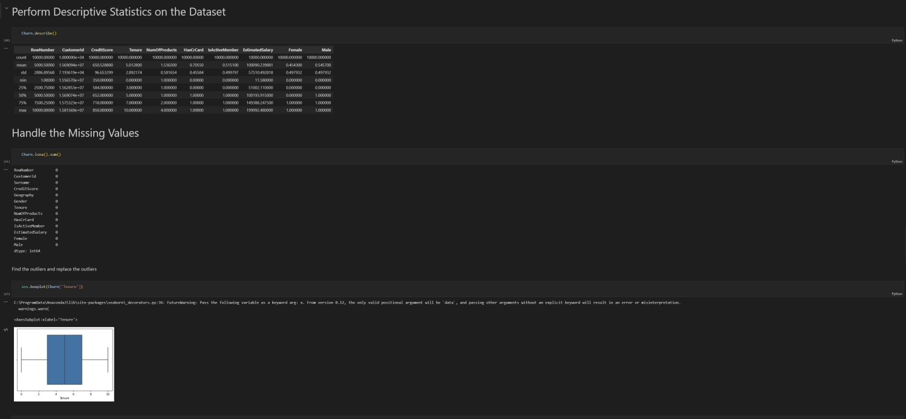

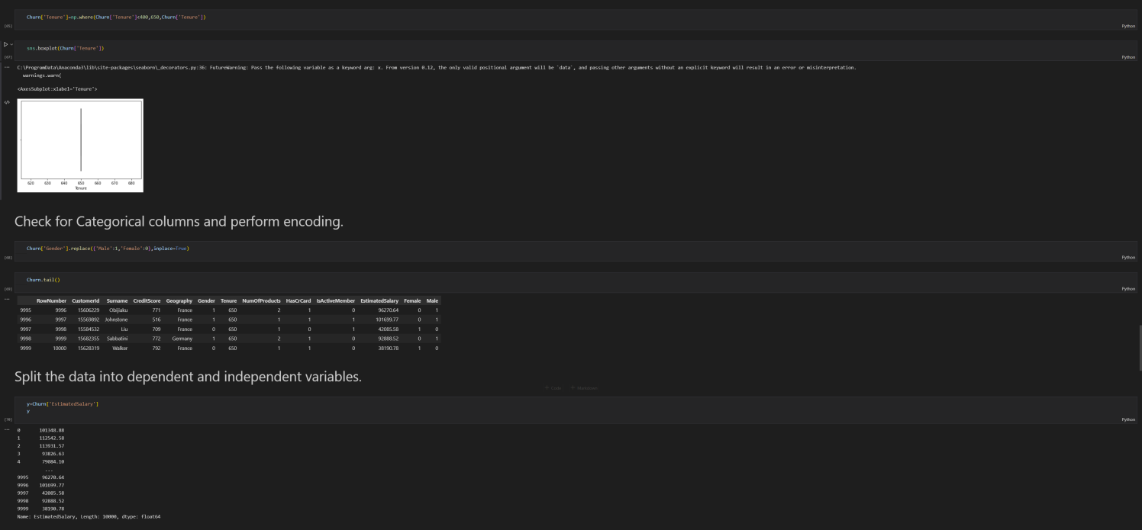

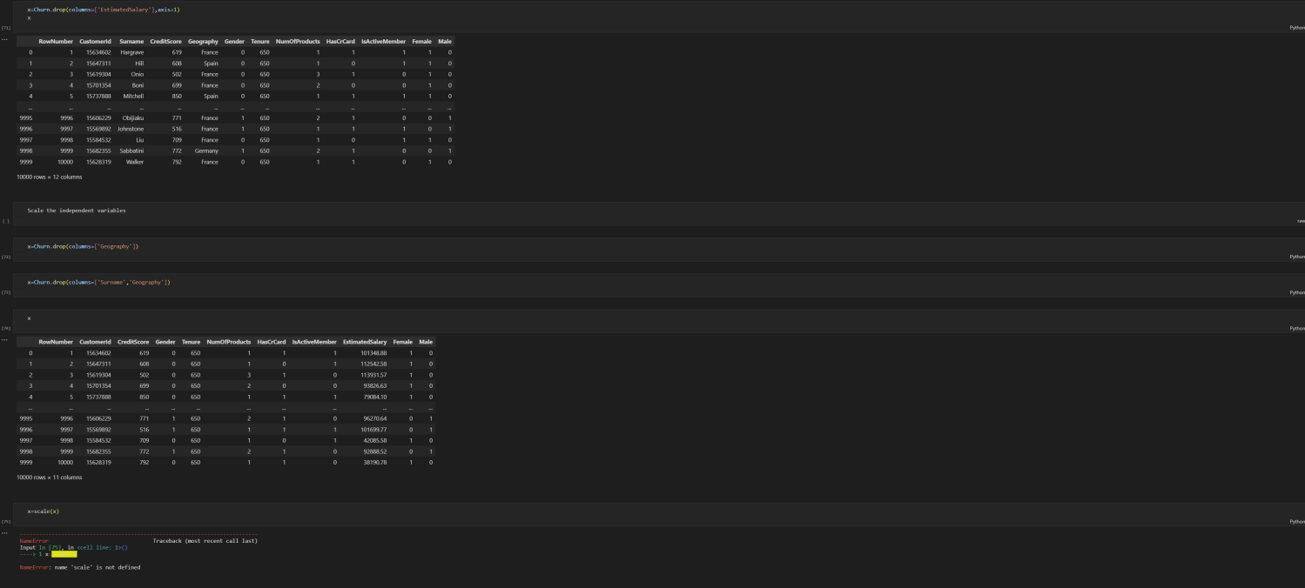

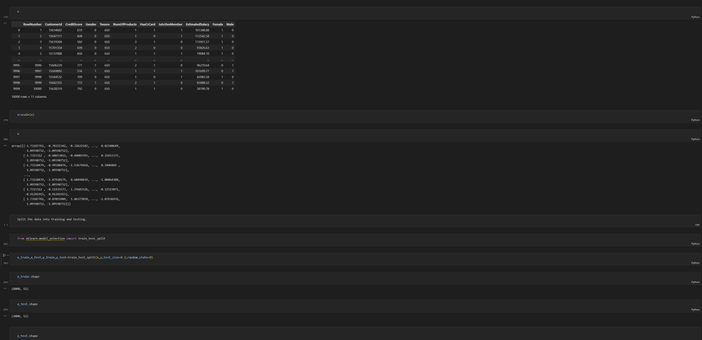

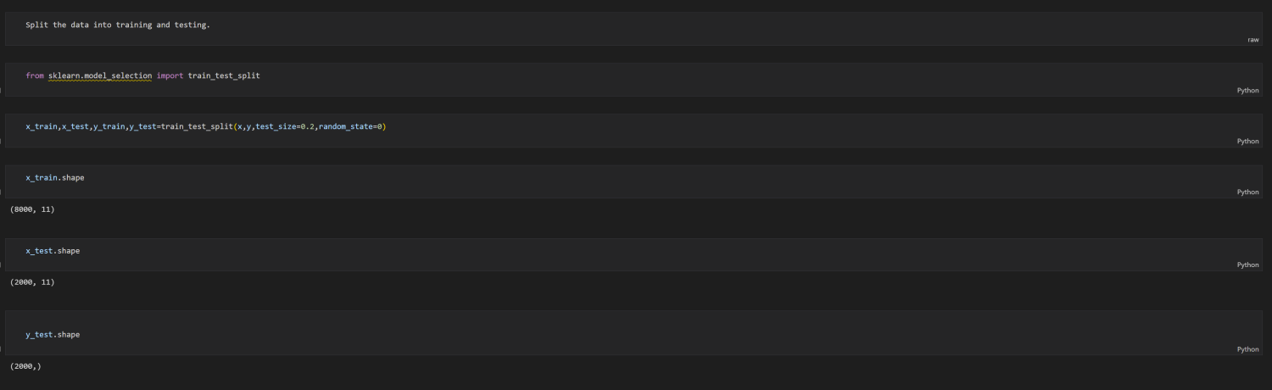

******************************THANKING YOU***********************************